Quick Guide to Appointment Scheduling

Introduction

This document provides a quick guide for Carriers and Vendors explaining how to schedule an appointment using the One Network system.

Appointment Scheduling

- Login to the One Network system.

- Find the Shipment that you want to schedule an appointment for.

To find the shipment, you can click into the global Search field located at the top of the screen.

Note - When you first click in the global Search field, you will see a Search By field and a Retrieve For field.

For the Search By field, please be sure that the drop-down choice is set to “Shipments - by Shipment Number”.

For the Retrieve For field, the default choice is “Last 30 Days” – if you want to look for shipments whose Pickup Date is older than 30 days, select one of the other choices from the drop-down list.

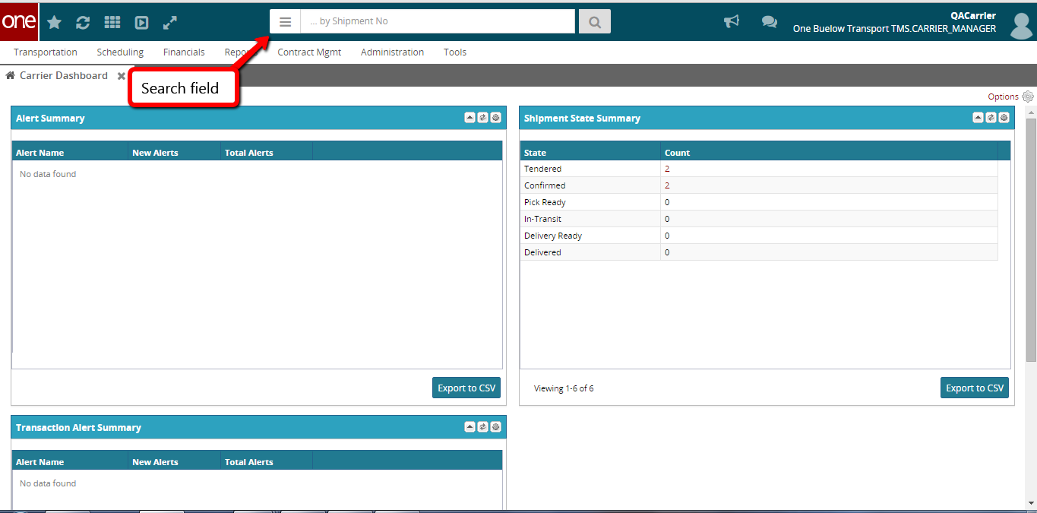

- Enter the Shipment Number / PO Number in the Search field and then press the Enter key on your keyboard.

When entering your Shipment Number / PO number in the Search field, you can enter a wild card symbol if you do not know or do not want to enter the entire PO number. The wild card is the asterisk symbol (*), and you can enter it either before the PO number or after the PO number.

A list of matching Shipment Numbers / PO Numbers will be displayed after pressing the Enter key on your keyboard.

IMPORTANT NOTE:

- When entering your Shipment Number / PO number in the Search field, If you are scheduling for Safeway or Kroger, enter an asterisk (*) symbol BEFORE the PO number (for example *123456)

- When entering your Shipment Number / PO number in the Search field , If you are scheduling for Dollar General, enter an asterisk (*) symbol AFTER the PO number (for example A1B2C3*)

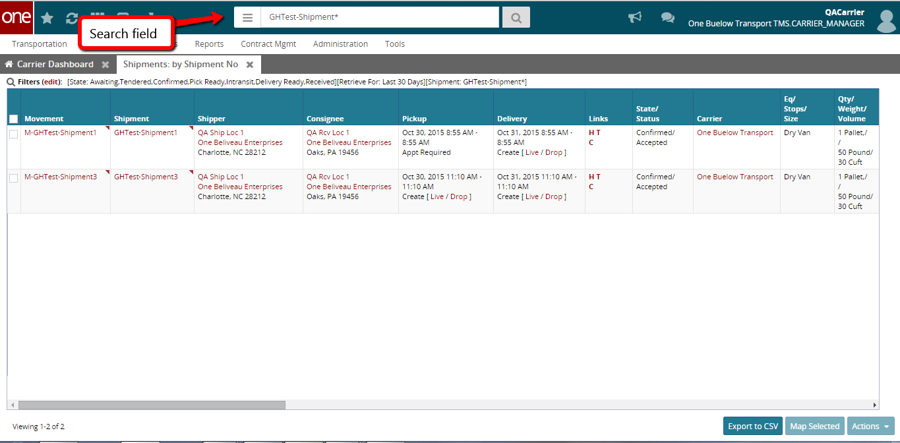

- Locate the Shipment Number / PO Number that you want to schedule an appointment for. Note - the Shipment Number / PO Number is listed under the Shipment column.

If you are scheduling a pickup appointment, click on the Live or Drop link located under the Pickup column.

If you are scheduling a delivery appointment, click on the Live or Drop link located under the Delivery column.

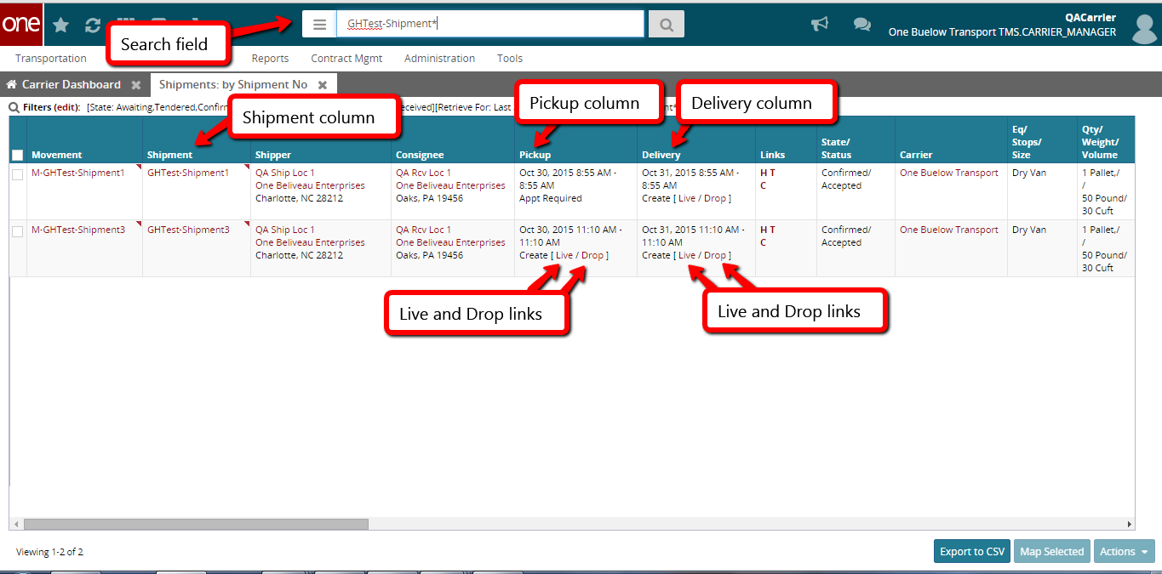

- An Appointment screen will then be displayed with a list of available appointment times.

To define how many appointments you want displayed on the screen, select one of the choices from the drop-down list in the Max Candidates field. Available choices are 5, 4, 3, 2 and 1.

Note – if there are no appointment times available in the system, the screen will show “no data”. If this happens, please contact your Hub to request an appointment.

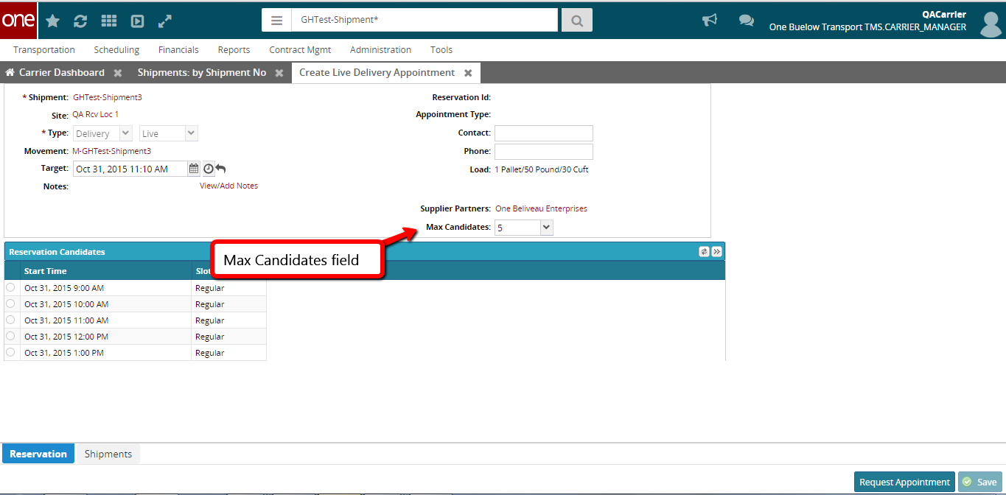

- Select the radio button next to your desired appointment time and then click the Save button on the bottom right corner of the screen to schedule the appointment.

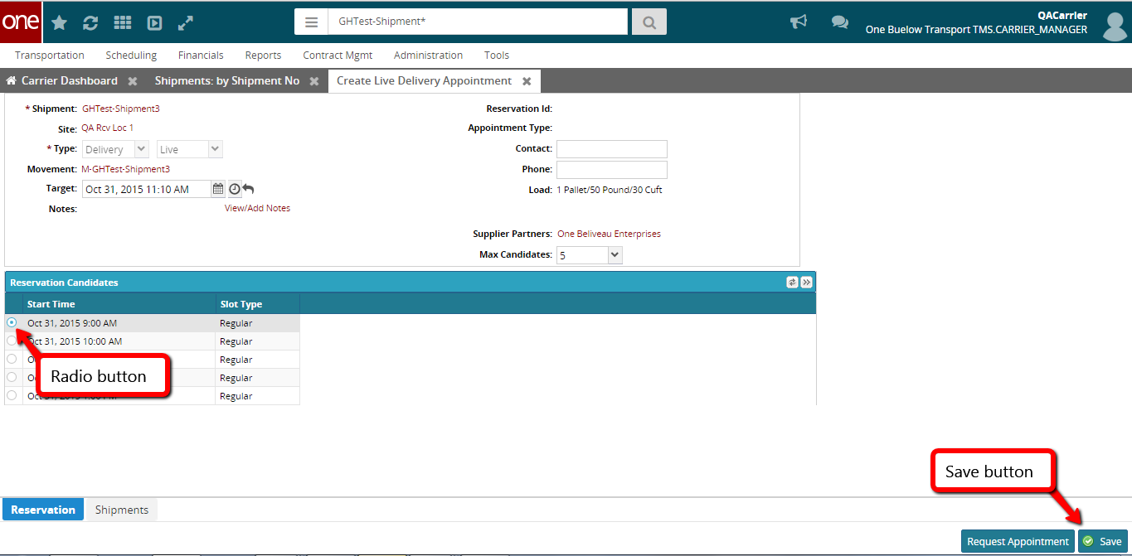
- After clicking the Save button, you will see a success message on the Appointment screen along with the Reservation ID / Confirmation Number for the appointment.

This confirms your appointment has been scheduled successfully.

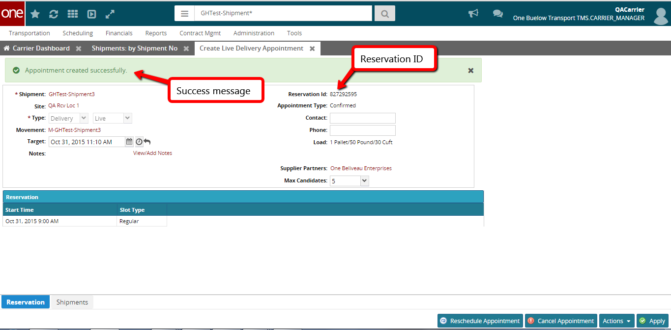

- Note - When first scheduling an appointment, if you would like to find available appointments for a different date and/or time, change the date and/or time in the Target field and then click outside of this field or click the Get Next Candidates icon.

The list of appointments will be refreshed and will be based on this new date and time. Select the radio button next to your desired appointment time and then click the Save button to schedule the appointment.

Note - To change the Target field back to its original date and time, click the Reset Target Date icon.

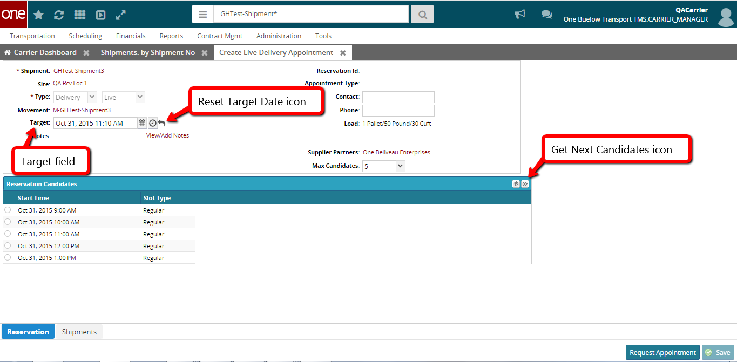

- If the Hub company has configured the application so a user has to enter a reason if changing the target date and selecting an appointment, a message will be displayed and you will need to select a choice from the drop-down list under the Reason Code field.

- Select one of the reason code choices and then click the Save button on the bottom right corner of the screen. A success message will be displayed that confirms your appointment has been scheduled successfully.

