To obtain the Duns & Bradstreet Number (DUNS Number) follow the step below:
For US Based companies follow the steps below:
- Go to https://iupdate.dnb.com

- Select “Get a D&B D-U-N-S Number”

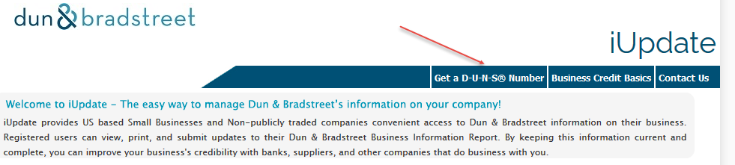

- Select “No” to this question.
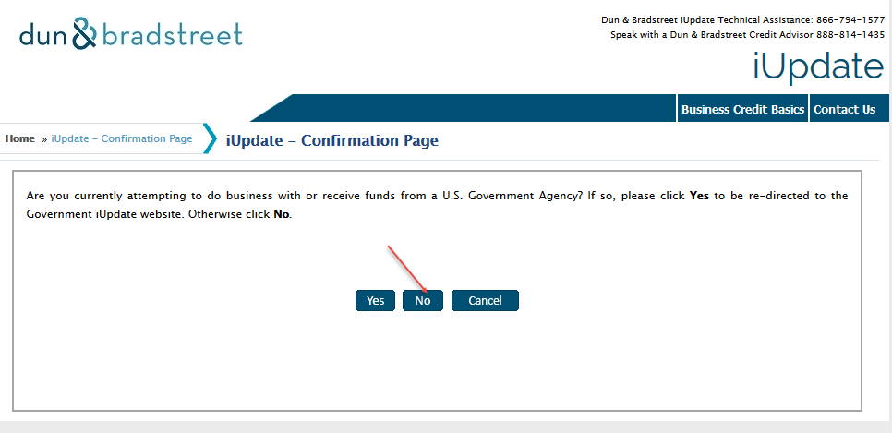

- Continue by answering the questions to obtain the D&B Number D-U-N-S Number

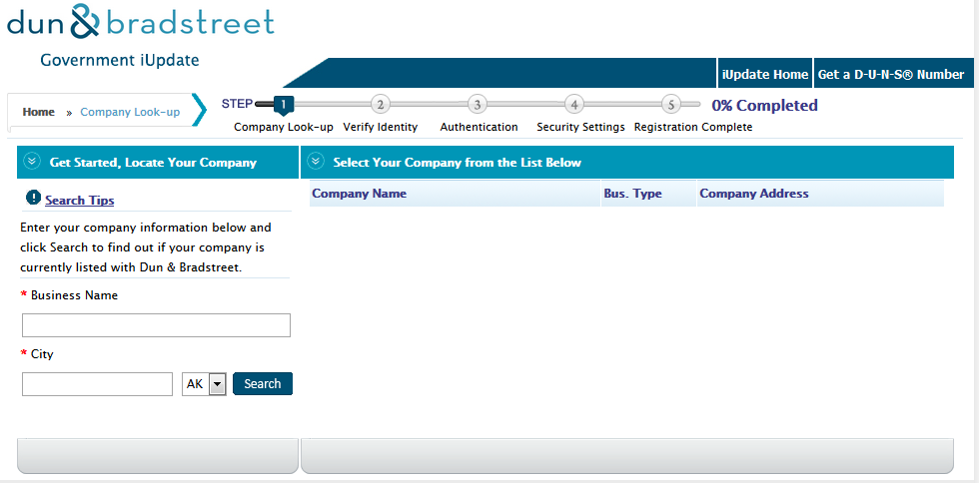

For Non-US Based companies follow the step below:
- Go to http://www.dnb.com

- Select the country of origin by clicking the dropdown menu at the top of the page

- Once the correct country is selected you will be able to obtain the D&B Number D-U-N-S Number for your company

