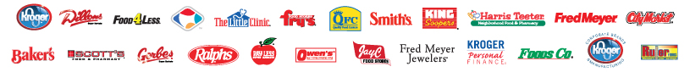
The Kroger Co. Ariba Purchase Orders and Invoicing rules and requirements

The Kroger Co. has implemented a procurement system named ePRO that will be used for the purchasing of store expense and equipment items. The Ariba Supplier Network will be used by The Kroger Co. to send purchase orders and to receive invoices from suppliers. However, it is very important to understand that this does not replace our current transmission method for our Warehouse Operations or Facility Maintenance (Viryanet). If you should have any questions regarding this transition and who is impacted, please email eproprocurementteam@kroger.com.

This document will clearly define our types of purchase orders that will be sent through the Ariba SN as well as the requirements for E-Invoicing via the Ariba SN. E-Invoicing will only be used for certain purchase order types, so it is very important that suppliers fully understand this document.

Purchase Orders

For each of these types, Kroger will be sending:

- New orders
- Change / Cancel orders
- Non – Catalog or Ad Hoc items
- Orders with attachments

*** Every supplier must be able to support each one of these order types. ***

For all purchase orders received through the Ariba N Network, Kroger is requiring all suppliers to provide the Order Confirmation and Advanced Ship Notice transactions. These may be sent electronically using the Ariba supported ConfirmationRequest and ShipNoticeRequest cXML or generated manually via suppliers account on Ariba SN.

***The sample PO presented below is just a sample. There are other variations of Purchase orders that Kroger will be sending. For instance, Kroger will also be sending Multi Ship To location orders. For these particular orders, the line level information will contain the ship to information and other necessary information associated to each line item. It is important for suppliers to recognize these orders and to pay close attention to the line level information.

Sample Capital Purchase Order Header Level Information

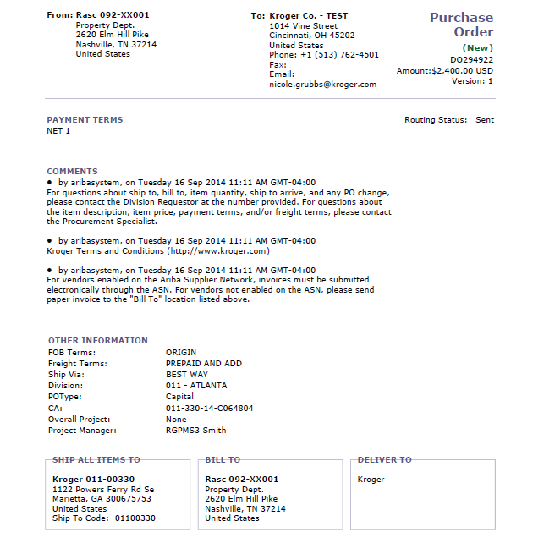
C
B
A

F
E
D

A: Purchase Order # - This must be identified on all invoices.

B: Comments – Comments will either be at the header or line level. Comments may inform suppliers of any special instructions concerning the order.

C: Other Information:
- Requestor – Name of person who requested the order. Phone number of person who requested the order. If supplier has questions regarding the order, they are instructed to call this person at the phone number listed below.
- Requestor Phone Number – Phone number of person who requested the order. Department – Kroger department this line item is associated with.
- Facility – Kroger location of this line item.
- Asset Location – Kroger asset location code for this item.
- Procurement Specialist – Corporate Buyer associated to this line item. Procurement Specialist Phone Number – Phone # for Corporate Buyer.
D: Ship to Address – Address where the order will be shipped. This information can be at the header level or the line level information.
E: Bill To – The Bill To is where the invoice must be sent, unless the invoice is being submitted electronically via Ariba SN.
F: Deliver To – This field contains the deliver to information. It may be a person’s name, store department or other information that should be included on the shipping information

Sample Purchase Order Line Level Information

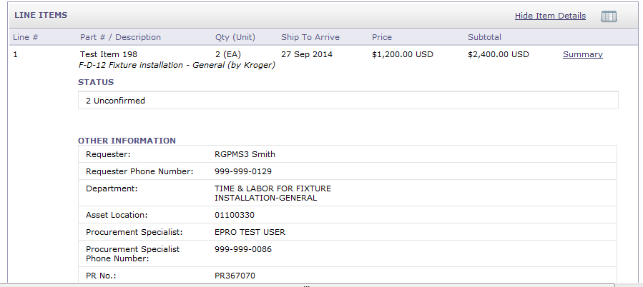
A

B

A: Line Items – Line items / line # contains the Supplier Part ID, (information comes from catalog or non-catalog item), Quantity ordered, Unit of Measure, Description of item, Ship to Arrive Date, and price for the line item.
- Ship to Arrive Date: This is the date the item must arrive at the destination and not earlier. If Ship to Arrive date is blank, please ship items at the standard rate without any expedited shipping charges.
B: Other Information:
- Requestor – Name of person who requested the order. If supplier has questions regarding the order, they are instructed to call this person at the phone number listed below.
- Requestor Phone Number – Phone number of person who requested the order.
- Department – Kroger department this line item is associated with.
- Asset Location – Kroger asset location code for this item.
- Procurement Specialist – Corporate Buyer associated to this line item.
- Procurement Specialist Phone Number – Phone # for Corporate Buyer.
- PR No: - Purchase requisition number that is associated to the order #.

Electronic Invoicing

Electronic invoices must be sent via Ariba Network for all Purchase Orders. This portion of the document will explain the details of the rules and requirements for submitting invoices through the Ariba SN.

The Ariba SN will reject invoices under the following conditions:

- Invoices that do not meet the defined specifications or are missing required data elements.
- Invoices greater than the Network supported file size of 4 MB or containing greater than 1,000 line items.
- Invoices that fail to validate against the Document Type Definition (DTD).

In addition to the above network validation rules, invoices will also reject on the Ariba SN under the following criteria.

- Invoices with tax or shipping specified at the line level; Kroger requires tax and shipping at the header/summary level
- Invoices which do not have the Ship From addresses at the Header level
- Non-PO invoices
- PCard/Credit Card orders
- Back-dated invoices older than 1 day prior to invoice post date
- Re-use of invoice numbers
- Invoices with a change in currency for unit price
- Change in Unit Price
- Change in Unit of Measure (UOM)
- Quantities on invoice exceeds those on purchase orders
- Line item subtotals on invoices exceed those on purchase orders
- Invoice net amounts exceed invoice subtotal
- Additional line items on the invoice greater than original PO
- Change in part number
- Invoices with a change in Ship To from what was on the PO
- Invoices with a change in Bill To Info from what was on the PO
- Header level Credit Memo and Debit Memo
- Invoice missing line item description
- Invoice missing bill-to address
- Invoice missing remit-to address

Tax Requirements

All Kroger Ariba purchases/invoices are to be processed through The Kroger Co. procurement company named “KPS, LLC” EIN 35-2476494. All purchases by KPS, LLC are made for resale and will therefore be exempt from Sales Tax. Under this process KPS, LLC will collect applicable sales tax from The Kroger Co. and its subsidiaries upon charging the companies for purchases through the procurement company.

Remit To Address Information
Remit-To Address is required on all invoices.

Shipping Address
Ship-to and Ship-from address information is required on all invoices.

*Ship to codes will be sent on the Purchase Order at the header level or line item level.

Shipping Amount
A shipping amount is required at the header level
The shipping amount should be zero if no actual charges are to be incurred

Special Handling
- Kroger will not accept special handling charges. These charges should be included in the Shipping Amount.

Ariba SN Invoice Status Updates

Suppliers will be able to check the status of the electronic invoices. Kroger will send the following standard status updates:

- Processing – The invoice has been received by Kroger, but has not yet been approved or rejected.
- Approved (or Reconciled) – all amounts in the invoice have been matched against amounts in the purchase order.
- Rejected – The invoice failed to reconcile. Kroger is rejecting the invoice. The Comments element should contain text explaining why the invoice was rejected, and the actions the supplier should take. Suppliers can view comments explaining why the invoice was rejected by accessing the invoice from their Ariba SN Outbox and clicking on the History tab. Suppliers can also configure their account to receive invoice status notifications via email on the ManageProfile>Email Notifications page of their account. Suppliers can resubmit a corrected invoice using a new invoice number.
- Paid – The invoice has been paid by Kroger.

