

The Kroger Company

Case Handling Automation System
Pallet, Case, and Slipsheet/Tie-sheet
Specifications

Developed in partnership by:
The Kroger Co. & Witron Logistik + Informatik

Date: October 19, 2009

Document Overview

Using advanced automated technology systems, Kroger has changed the way product is handled within its distribution processes.

With the new system, pallets are received and inducted into the system in a uniform manner. Subsequently, each case flows through the same standardized processes throughout the system. The system’s output is a mixed SKU pallet, ready for delivery to our stores.

This document is broken into the following four sections.
- Pallet Receiving
- Pallet Specification
- Case Specification
- Slipsheet/tie-sheet Specification

Your active cooperation in meeting these specifications is required.

When a pallet is being received at an Automated Warehouse it is critical that the case GTIN information be readily available for the Receiver to scan. This assists the system in recognizing and processing the pallets more efficiently.

Currently Pallets are shipped with various labels and pallet/case identifiers used to identify the Ship from or Ship to locations and other information. In the case of standard cardboard cases, the 15 digit GTIN is typically printed on the sides and is readily available to be scanned for receiving.
Pallet Receiving

The opportunity arises for better case GTIN access on the following products:

Bagged items such as Pet Food, Rice, Flour, etc that are shipped as a case pack of 1 – the GTIN is often on the underside of the product and is difficult to get to.

Bulk Paper items that are not in cardboard and ship in a case pack of 1

Multipack Water or beverages that ship as a case pack of 1

Club pack items that ship as a case pack of 1

All of these types of pallets require the Receiver to physically lift the product and attempt to scan the package GTIN to validate the pallet. This is ackward and time consuming especially if the pallet is shrink wrapped and the GTIN is difficult to get at.

For this reason, we are requested that when you ship these types of product to our automatted facilities, that you place a scannable 15 digit Case GTIN label on all 4 sides of the pallet. See examples below:
Current Label Type – cannot scan bar codes to receive
Scannable Case GTIN Label – Place on all 4 Sides of Pallet

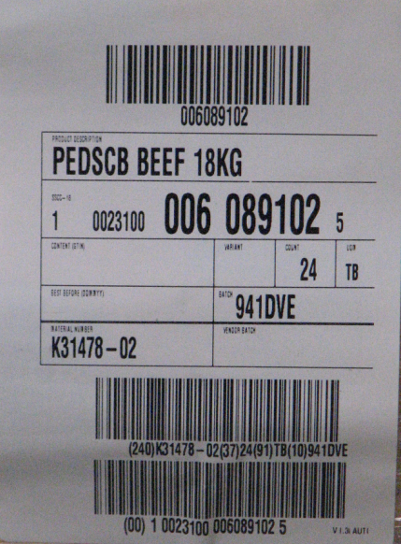
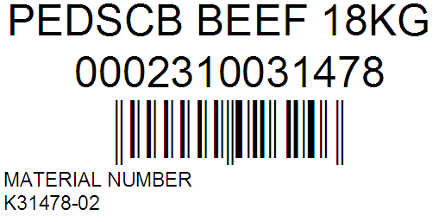

After being received on the dock, pallets of product go through specific handling points in the system. In order to be processed, they must meet the following requirements.
Pallet Specification

- Pallets may not be bigger than 40” by 48”.
- Pallets must be Stringers (Chep, White Wood) or Block.
- The tie footprint may not be larger than 40” by 48”.
** Note there is a +2” in each direction to accommodate for product shifting
that may occur during transportation.**
- The tie footprint may not be smaller than 36” by 44”.
- Pallets must be shipped with complete, even layers.
- On tray wrapped product, the total voids through the layer can not exceed 45 sq. in.
- The pallet height may not be taller than 106”.
- The pallet weight may not exceed 2755 lbs.
- Cases on the pallet must retain the same shape both while being held together by stretch wrapped and after the stretch wrap is removed. This means that the case layers on the pallet can not expand or marshmallow out after the stretch wrap is removed.
- Any stabilizing glue, friction enhancers, or other adhesives and tapes must be 100% disintegrated by the time the pallet enters the system. It is strongly preferred by Kroger that these product not be used at all.
- Pallet stickers or any other form of identification must be placed on a single case. Any over-lap between layers is potential for errors.

Product received only on a slipsheet is handled using a special forklift attachment. The slipsheet is removed on the receiving dock and the product is then set on a pallet which is then handled as above.

The use of slipsheets vs. pallets on your shipments should be discussed and approved by the Kroger Co. Specific requirements apply to this process.

Do not make any changes from shipping on pallet to slipsheet without first receiving approval from The Kroger Co.

Case Specification
Like the pallets, the cases also go through specific handling points and processes in the system. While the system is extremely versatile in the types of product cases it handles, there are some requirements which cases must adhere in order to be processed flawlessly.

- Products must be able to be lifted by the top of the case for a period of 30 seconds and remain 100% in-tact. In-tact is defined as:
  - Box bottoms remaining 100% closed
  - Box lids remaining 100% closed.
  - Adhesives (tape or glue) must be able to keep cases sealed shut with no sagging of the bottom of the case. During transport to the site and on the lot in trailers, case temperatures may reach up to 160º Fahrenheit. Adhesives must be specified for these temperatures.
  - Shrink wrap around tray packs must remain tight, holding the tray pack completely together., the shrink wrap must not deform or stretch
- Any slipsheets and tie-sheets used on a pallet must meet Kroger’s slipsheet & tie-sheet specification. Please refer to the section titled “Slip/Tie-sheet Specification.”
- The upper surface of product cases must be substantial enough to have up to 150 mbar (4.4 inches of mercury) of suction applied without the case falling apart.
- The case can not have any loose tape, cardboard, or any other things hanging from them.
- Cases can not be shorter than 3.5”.
- Cases must be 100% free from any tape or adhesives holding the case layer together.
- The “bulls-eye” on tray packs must be small enough so that when going down an incline of 15º all of the product units remain in the case package.
- Cases can not be larger than 26” by 18”.
- Cases can not be taller than 19”.
- Cases can not be taller than 1.7 times the shortest width of the case.
- Minimum case length to width dimension is 6” by 7”.
- The bottom of the cases must strong enough to be lifted by set of pins with a diameter of 0.2”
- The sides of the case must be strong enough that they can be pulled with a rake using rolls with a diameter of 0.8” and a height of 1”inch and a spaced 2” apart.
- The sides of the case must be strong enough to be pushed with a force equivalent to the gravity weight of the case.
- The case shape needs to be rectangular and rigid to be pushed with a 6” pusher
- The bottom of the case must be constructed of material that can slide across a surface made of Polyurethane material (70-90 shore), and then set onto the store pallet.

The system is designed to handle slipsheets and tie sheets at the depalletizer. This section outlines the requirements that slipsheets and tie-sheets must meet in order to be processed through Kroger’s depalletization system. Slipsheets and tie-sheets that do not meet these requirements are known to cause the automatic system to fail.
Slipsheet/Tie-sheet Specification

Required Design
Slipsheet/Tie-sheet Size

- The footprint of tie-sheets between product layers can not exceed 40” x 48”.
- The footprint of a slip-sheet between a pallet and the bottom product layer can not exceed a 40” x 48” footprint with the exception of no more than a 4” lip on two adjacent sides in order for push-pull truck to handle the pallet.

- The slipsheet/tie-sheet must be a single unit.
- Double slipsheets/tie-sheets laid side-by-side on a single pallet or on top of case layers can not be accepted.
- Two slipsheets/tie-sheets stacked on top of each other in any configuration cannot be accepted.

Slipsheet/Tie-sheet Stiffness

- The material used for a slipsheet/tie-sheet must be sufficiently hard so that the weight of the cases will not deform or cause significant indentations on the slipsheets or tie-sheets.
- The slipsheet must not have any folds other than the pull tabs on two edges. Tie-sheets must have no folds.
- Slipsheets/tie-sheets can not have beveled edges. Nor can the edges be bent to form a tray or lid. The unit must be as completely flat, except for the “pull” edges.
- The 40” x 48” slipsheet/tie-sheet must be sufficiently stiff so that when overhanging off of a supporting structure from a distance measuring 500 mm, the slipsheet/tie-sheet does not sag or deflect more than 50 mm in distance. See figure 1 below.

Figure 1
500 mm
Flex
≤ 50 mm
Supporting Structure
Slipsheet

Slipsheet/Tie-sheet Specification (continued)
Slipsheet/Tie-sheet Adhesive
- The coefficient of friction (COE) between the cases of product and the slipsheets/tie-sheets must be < 0.35.
- If an added adhesive must be used to hold the product to the slipsheet/tie-sheet. It must be a type of adhesive that disintegrates so that the COE listed above is met by the time the product arrives to our distribution centers.

Slipsheet/Tie-sheet Material

- The under-side of the slipsheet/tie-sheet and the top-side of the slipsheet/tie-sheet must be constructed of the same material. Refer to the recommended conditions as to what type of materials to use.

Recommended Design

Slipsheet/Tie-sheet Material

- Slipsheets/tie-sheets made from corrugated cardboard are known to perform well through the automated system.
- Cardboard thickness of at least 2 mm helps give the slipsheets/tie-sheets added stiffness.

