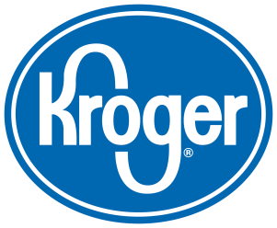
Palm Oil Policy Statement
Palm oil has become the world’s leading oil crop and today accounts for roughly one-third of the global vegetable oil production. This oil has grown in popularity within the food industry as a cooking oil, shortening, margarine, milk fat replacer, and as a cocoa butter substitute.
Some organizations have raised concerns that unless it is sourced responsibly, palm oil can contribute to deforestation in parts of the world.
Kroger recognizes the benefits of using responsibly-sourced palm oil in all of our Corporate Brand products. We also recognize this is a developing issue for many of our suppliers, and we are committed to working with them to improve sustainability in the palm oil production supply chain.
By the end of 2015, Kroger will purchase 100% of palm oil from suppliers certified by the Roundtable on Sustainable Palm Oil (RSPO).
Kroger will disclose its progress toward this goal in its annual sustainability report, and continue to support public policy efforts for a moratorium on palm oil expansion in rainforests and peat lands.

